
Westside High School Retake Policy
District Policy on Retakes:
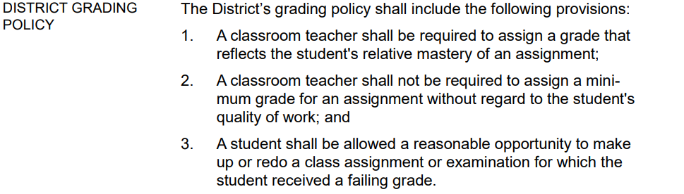
Source: Board Policy, EIA, Local
At Westside, a retake is an assessment that matches the rigor and objectives of an original exam. Retakes often increase a student’s grade, but the primary purpose is a second opportunity to demonstrate mastery of course material.
Retakes should be similar in length and rigor to the original assessment and must NOT be designed for the purpose of raising a grade (i.e. significantly shorter assignment, completion grade, etc.)
Retake Guidelines
- All teachers must follow Policy EIA (Local).
- All major grades are eligible for a retake.
- Assignment must have been attempted to be eligible for a retake.
- Retake must be completed within two weeks of original test grade being posted in PowerSchool.
- Retakes are for failing grades (below 70).
- Students with absences still have the opportunity to have a retake for a make-up exam.
- Retakes are not allowed for final exams.

Retake Process
- Prior to retaking, students must complete one or more of the following, determined by the teacher:
  - Attend necessary tutorials
  - Complete alternative assignment
  - Complete necessary homework
  - Complete test corrections
- After a student completes a retake, the teacher has a week to grade the assessment.
- All retake grades are capped at a 70.

